ANALYSIS ON SHOPPING BEHAVIOUR DATASET

PROJECT REPORT SUBMITTED
IN FULFILMENT OF THE REQUIREMENTS FOR THE COURSE
STAT 112
INTRODUCTION TO DATA PROCESSING AND VISUALIZATION
DEPARTMENT OF STATISTICS OF
MIDDLE EAST TECHNICAL UNIVERSITY

BY
Yağmur Çınar
2561157

- INTRODUCTION:
This report examines several important variables in the dataset, building the basis for an in-depth analysis of shopping behavior by exploring demographic data, transaction details, geographic insights, and product attributes. There are 13 variables which can be explained such as:

- Customer ID: It's a special ID, kind of like a shopping fingerprint.
- Demographics (Age and Gender): Shows how old customers are and their gender.
- Transaction Details (Item Purchased, Category, Purchase Amount): Shows what customers buy, category of what costumers bought and how much they spend on.
- Geographical Insights (Location): For checking where customers live and shop.
- Product Attributes (Size, Color, Season): Shows details of item which are size, color, and season that item purchased.
- Customer Satisfaction (Review Rating): Shows customer satisfaction of the item purchased.
- Subscription and Loyalty (Subscription Status, Frequency of Purchases): To see if customers sign up for memberships and how often they shop.

Questions Researched:
- Is there a correlation between the previous purchase count and purchase amounts according to items purchased?
- On which item people spent more money on summary?
- Which items were spent more money on average through the seasons?
- How does the subscription status affect the previous purchase amounts?
- Is there a relationship between age and average purchase amount?
- Do customers who use promo codes tend to make larger purchases on average?
- Does the review rating affect the purchase amount of the item?
- Which state has more purchase rate among California, Michigan, New York and Pennsylvania?

- DATA CLEANING AND TIDYING STEPS:
In data science, data visualization, and data analytics, data cleaning is the process of organizing and correcting mistaken unreliable, and disorganized formatted data to produce accurate results. These steps were used to clean this data set:
- First, two data sets were combined using Tableau.
- Only the row displaying 100 rows had been changed in spite of the fact that the data sets contained 3900 data points.
- Because Customer ID represents nominal data, it was converted from a number to a string.
- The review ratings have been simplified by eliminating any unnecessary zeros. The review rating was reduced to decimal 1 in the number format section by right-clicking on it in the measure section.
- By right-clicking, the location was switched from a geographic role to a state. Thus, a map can be created correctly.
- EXPLORATORY DATA ANALYSIS:
- Is there a correlation between the previous purchase count and purchase amounts according to items purchased?
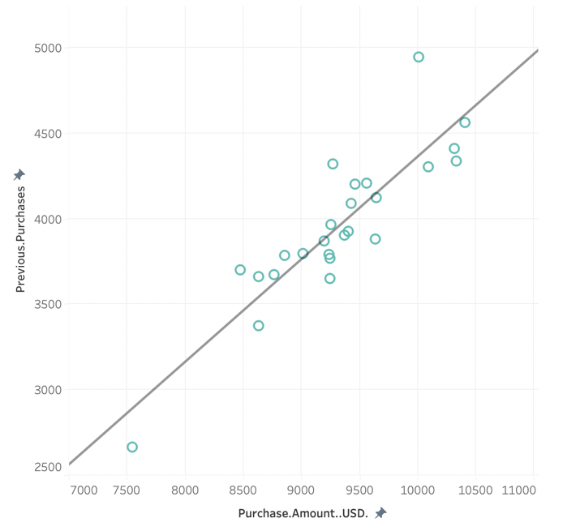
To answer this question, scatter plot was used because there are two different numerical values in question which are previous purchase count and purchase amounts in USD. There is a strong linear relationship between two numerical values when we consider them by items purchased. Reader can interpret that products purchased more previously are the ones people spend more money on. So that it can be said that people tend to buy items which are preferred more formerly because previous purchase amount might give confidence about their potential purchase. Else it can be said that people tend to affect from current consuming culture.

- On which item people spent more money on summary?
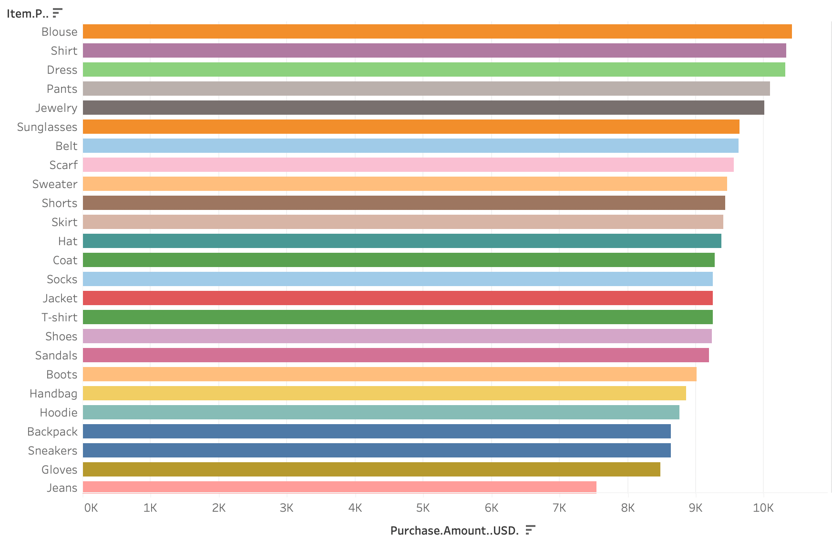
In overall, people in the examined data set were spent more money on blouses on summary.

- Which items were spent more money on average through the seasons?

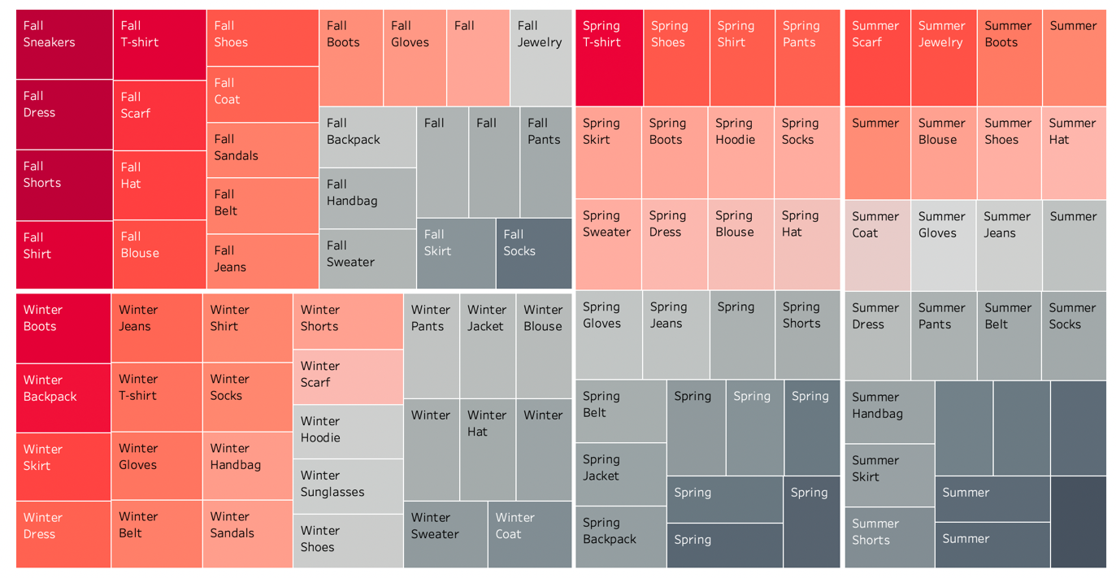
From this treemap, what items purchased was the ones which have been spend most money on can be observed by seasons. In fall, people might have spent more money on sneakers as a school needing because schools are starting in fall each year. In winter, boots were spent more money on since people obviously need boots during winter. In spring, people spent more money on t-shirts, it might be because weather conditions start to get warmer. Lastly people might spend more money on scarf in summer to use it as an accessory. This treemap can help companies to detect which item to launch or market more during different seasons.

- How does the subscription status affect the previous purchase amounts on average examined by item purchased?
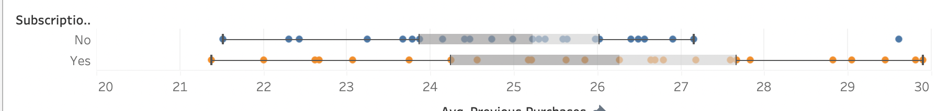
While comparing categorical and numerical values, using box-plot is an efficient way. Also, we can observe the five number summary statistics with using a box-plot and detect outlier values. Median values for previous purchase amounts are 25.2 for no subscription and 26.2 for when there is a subscription. However, range of items purchased when there is a subscription is broader than while no subscription status includes an outlier which is way bigger than the upper whisker on box-plot. In addition, box-plot for no subscription status has left skewed distribution as same as the box-plot of when there is a subscription. So that, it can be said that subscribed customers do shopping more consistently than not subscribed customers.

- Is there a relationship between age and average purchase amount?
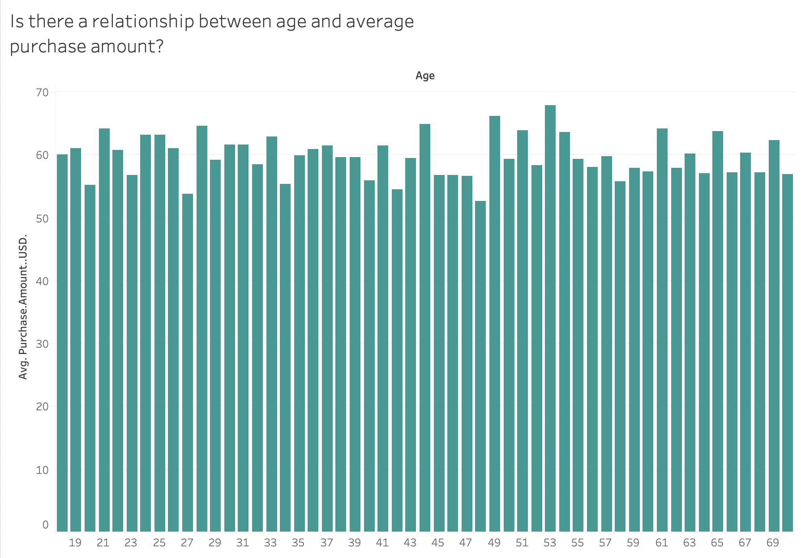
To answer this question, bar chart was used because it can be easily seen that if there is any related condition between the two variables given. As can be seen by the bar chart, even though there is a one peak point, there is no relationship between age and average purchase amount because average purchase amount varies inconsistently above ages. However, it is seen the most age group that spent more money on their purchase is 53-year-old people and the group that spent the least money are people aged 48.

- Do customers who use promo codes tend to make larger purchases on average?
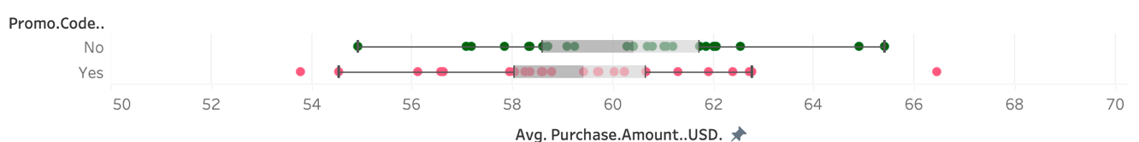
Box-plot again used to answer this question since there are two numerical variables and to the distributions, detect outliers. If we go through the box-plots, it can be seen that while no promo code used one has more dispersion, promo code used one has two outlier values one is lower that lower whisker and the other one is higher than upper whisker. First median is 60.4 and higher than the second one which is 59.4. No box-plot almost has a bell-shaped distribution while yes box-plot has a left skewed distribution. It can be said that using promo code does not cause customers make larger purchases. However, it can be seen that the biggest and smallest purchases made by using promo code so using promo code displays an inconsistent role on purchase amount.

- Does the review rating affect the purchase amount of the item?
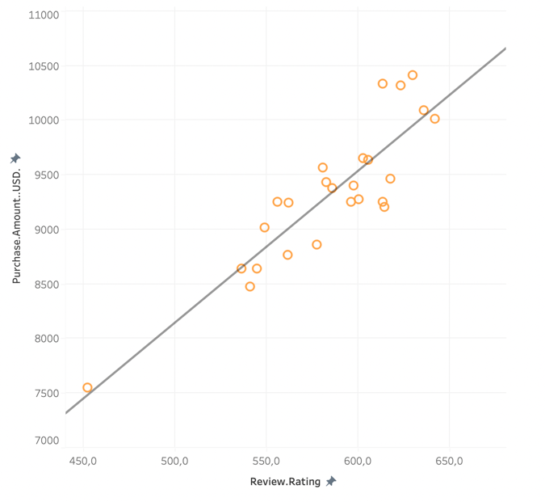

To compare two numerical variables, scatter plot used again. It can be clearly seen that there is a positive linear relationship between review rating and purchase amount of the item. Thus, as review rating increases, the purchase amount also increases. Companies should market and launch more the items which rated more in previous purchases because people clearly prefer these items more.

- Which state has more purchase rate among California, Michigan, New York and Pennsylvania?

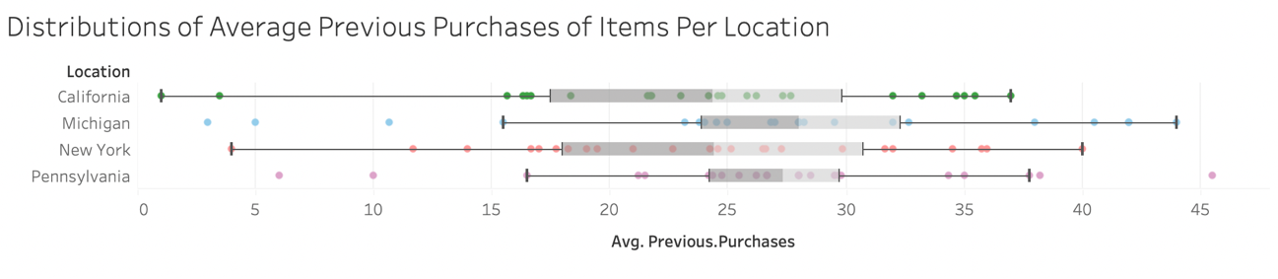
California has left skewed distribution, Michigan has right skewed distribution, New York has left skewed, and Pennsylvania has almost bell-shape-distribution according to these box-plot. Pennsylvania has more outliers than the others while California and New York don’t have any outliers. Michigan has highest median value while California has the lowest one. While California and New York have almost same dispersion, Pennsylvania has the lowest dispersion between 4 of them. According to these box plots, we can say that people live in Michigan more tend to make bigger purchases consistently than the other ones.

- CONCLUSION:
In summary, looking at the data helped us learn a lot about how people shop. We used different pictures like scatter plots, treemaps, and box plots to understand the connections between things. Overall, these discoveries can help businesses improve how they sell things, manage their products, and make customers happy. Knowing the details about how people shop in different ways can help companies make smart choices and adjust how they do things to meet the different needs of their customers.

- TABLEAU LINK:
https://public.tableau.com/views/YamurnarShoppingBehaviourDashboard/Dashboard1?:language=en-US&publish=yes&:display_count=n&:origin=viz_share_link

